

**NAMA : SHABRINA QOTTRUNNADA**

**KELAS : 1G**

**ABSEN : 24**

**NIM : 2341760160**

**JOBSHEET 9**

**EXPERIMENT 1**

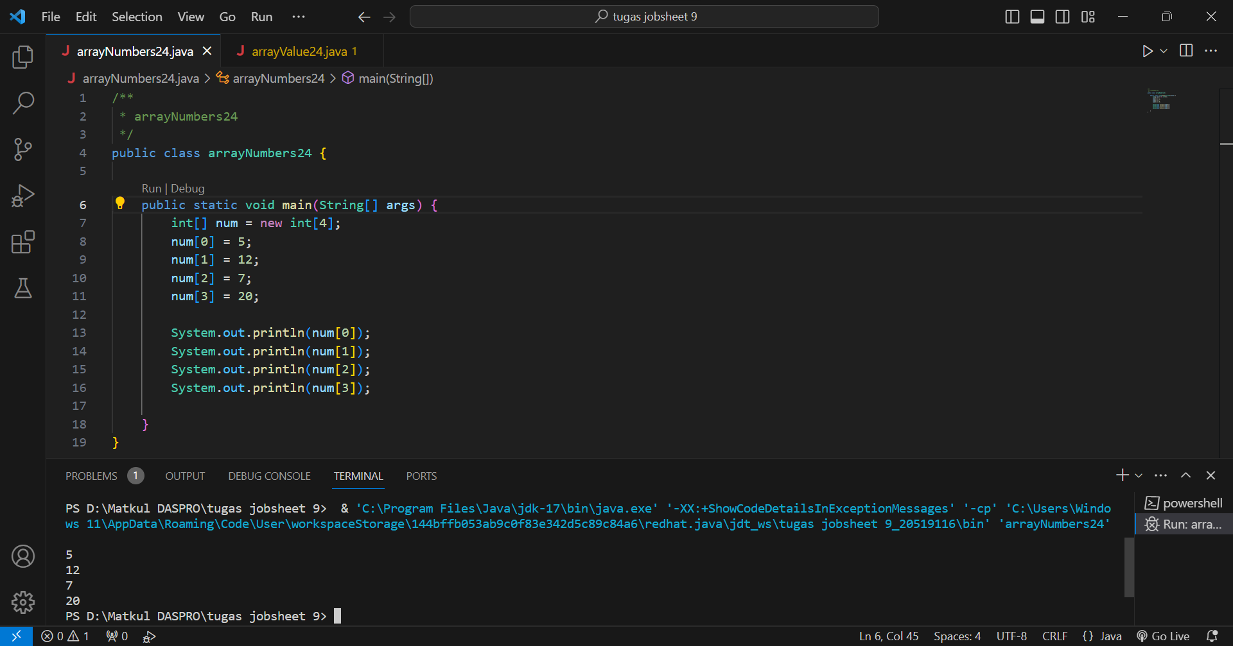

Questions!

1. If the contents of each element of the array num are changed with numbers 5.0, 12867, 7.5, 2000000. What happens? How can it be like that?

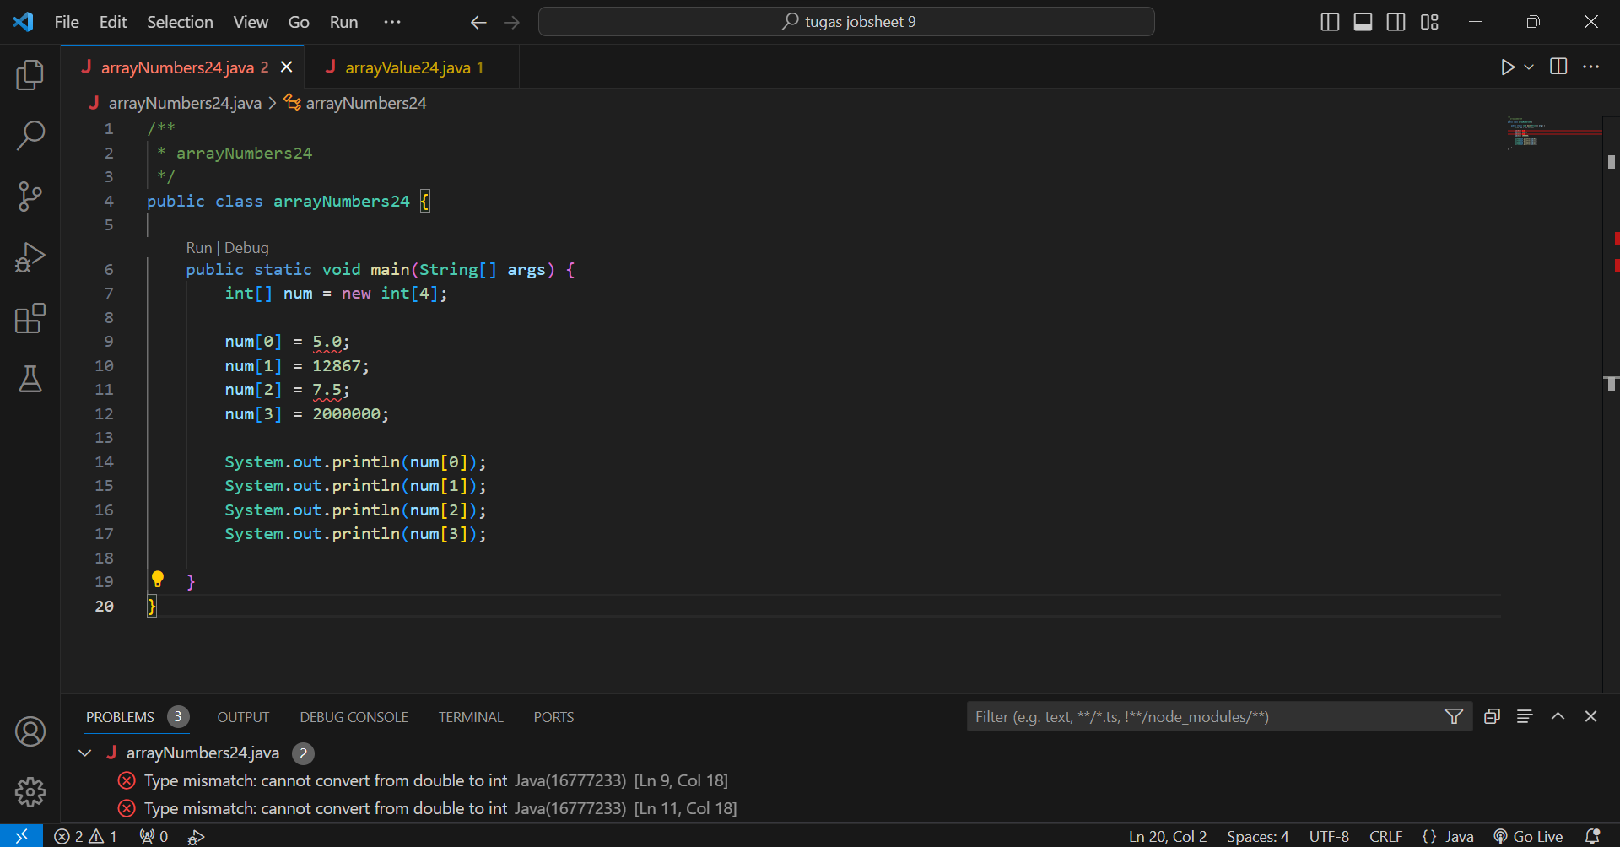

When each element of the bil array is changed according to the result requested in the problem, the result is an error and cannot be run. and why can this happen? because the data type does not match.

1. Modify the program code by initializing the array elements at the same time when declaring the array.

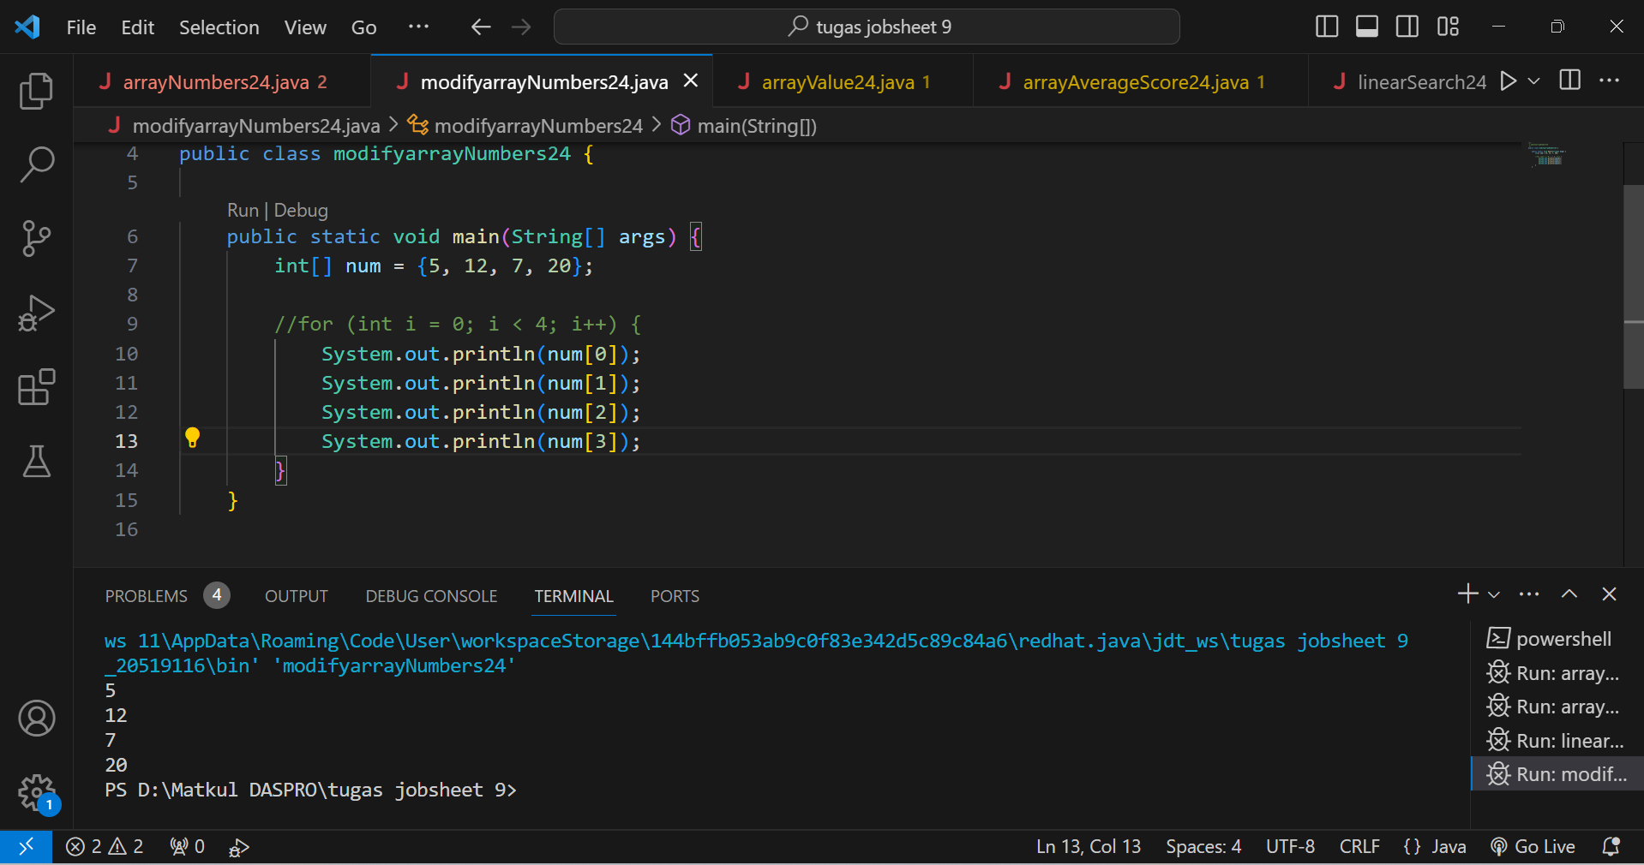

1. Change the statement in step 6 to be like this What is the result? How can it be like that?

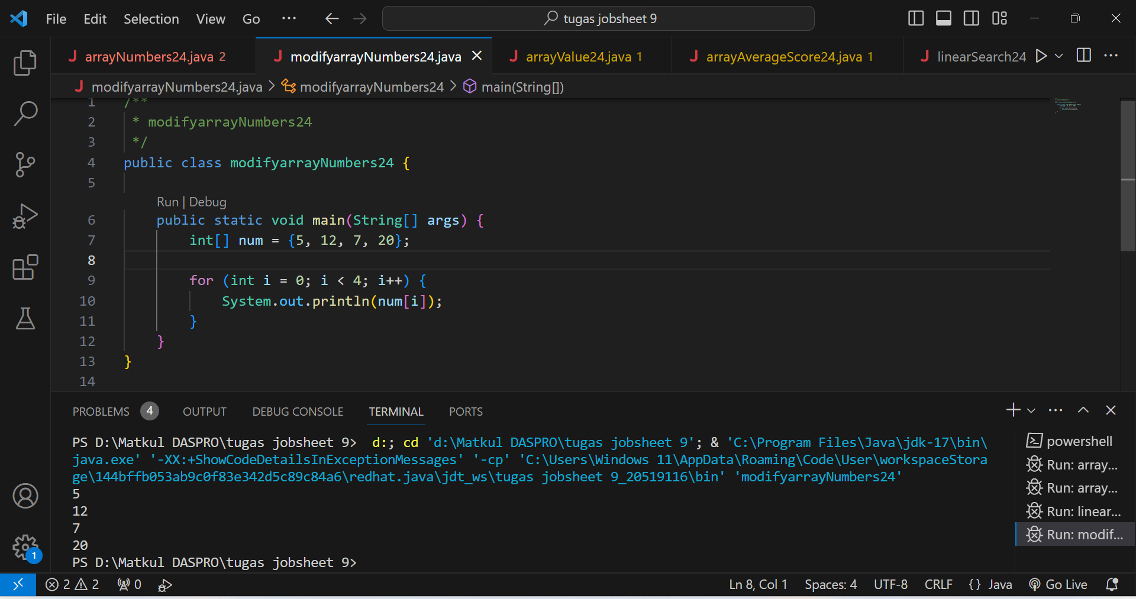

The result when run is the same as the previous one, why? because the function of the previous statement and the new one are the same, therefore the output is the same.

1. If the condition in the for-loop statement is changed to i <= 4, what is the output of the program? Why is the result like that?

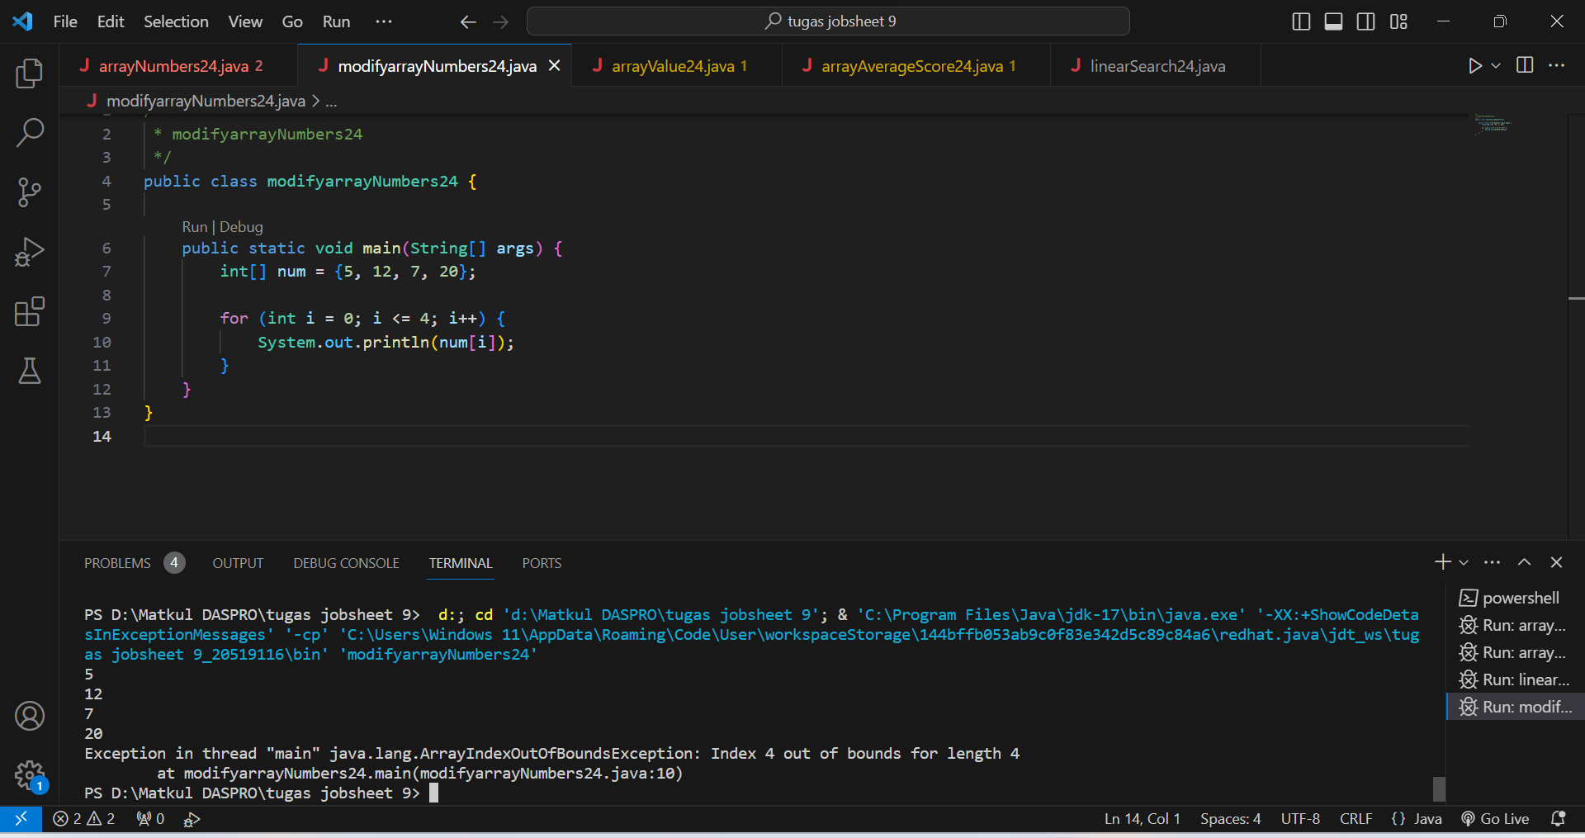

Why is there an inscription "Index 4 out of bounds for length 4" that appears? because the index value starts from 0, while in the statement above **i <= 4**, so the total index = 5 then we have to add the code **num = new int[5];**

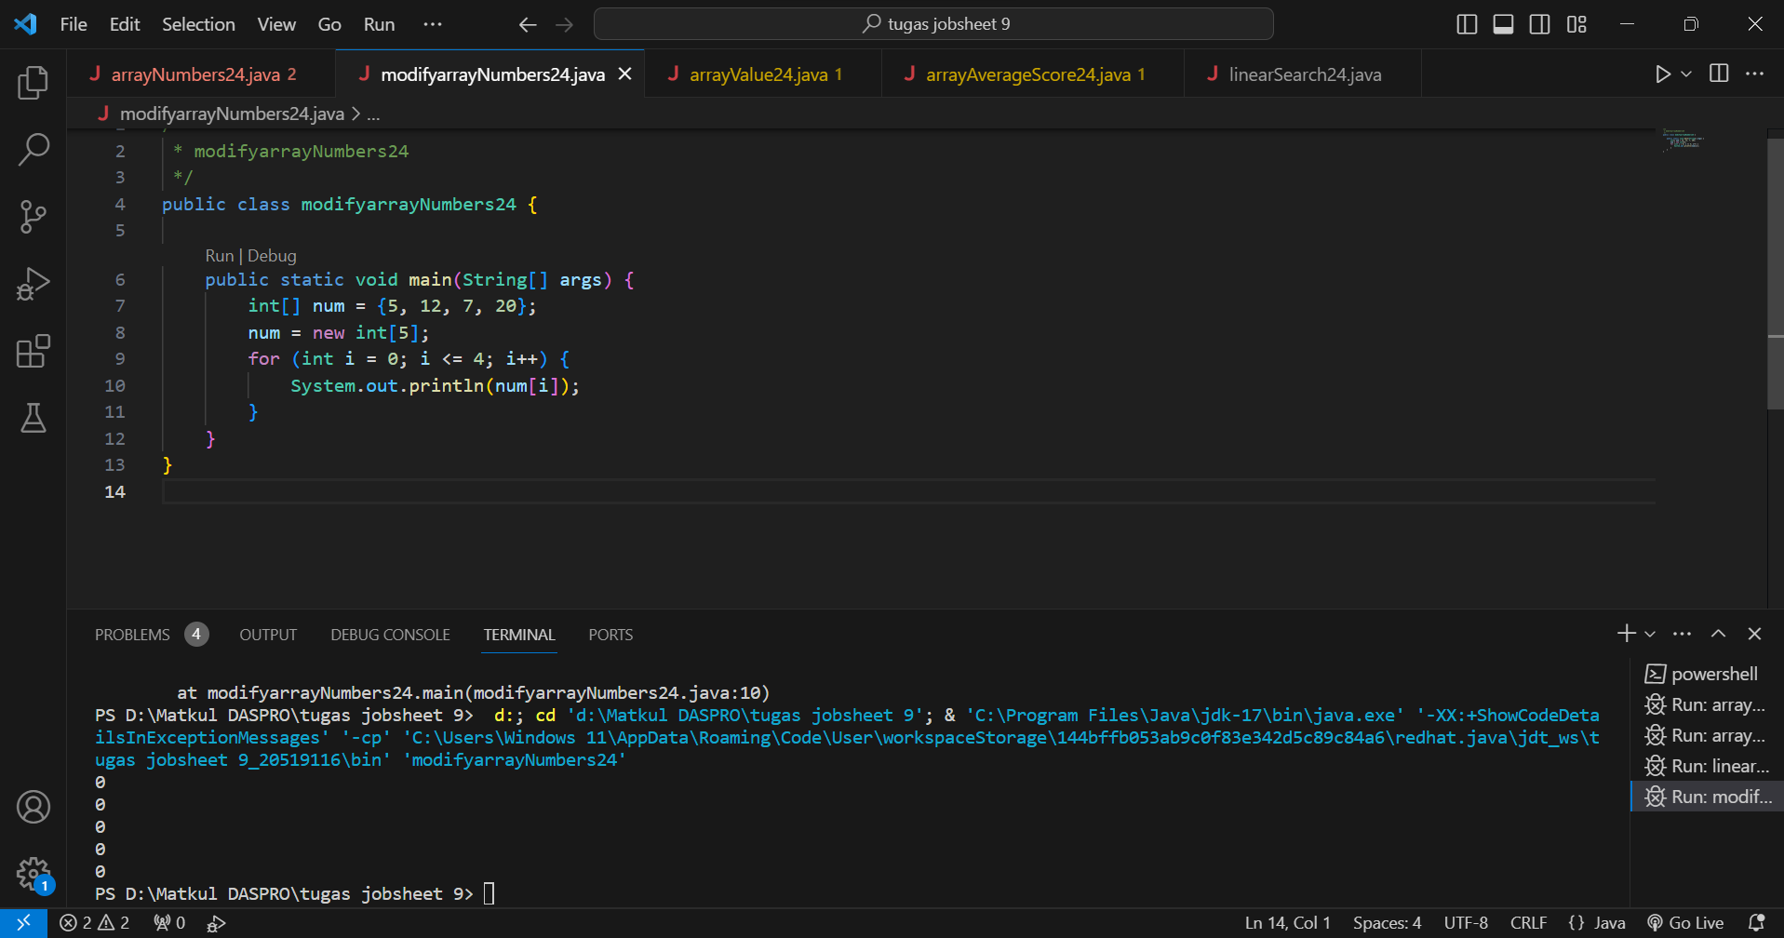

Then after we run the output will be 0 all 5 numbers because the data type is Boolean.

1. Commit and push the changes to GitHub.

**EXPERIMENT 2**

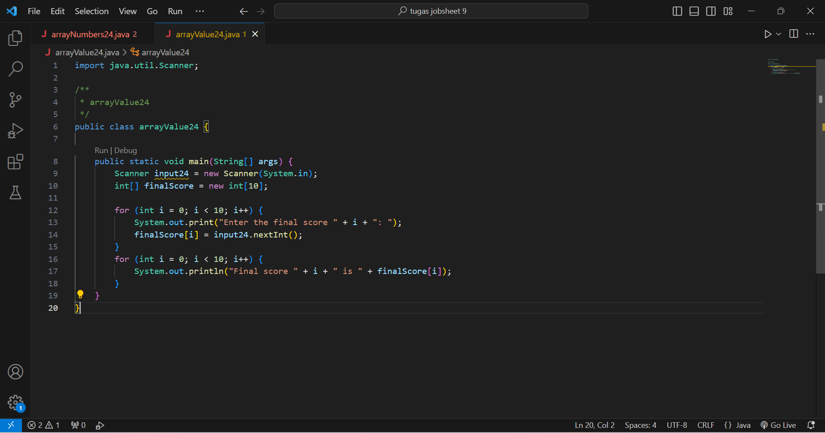

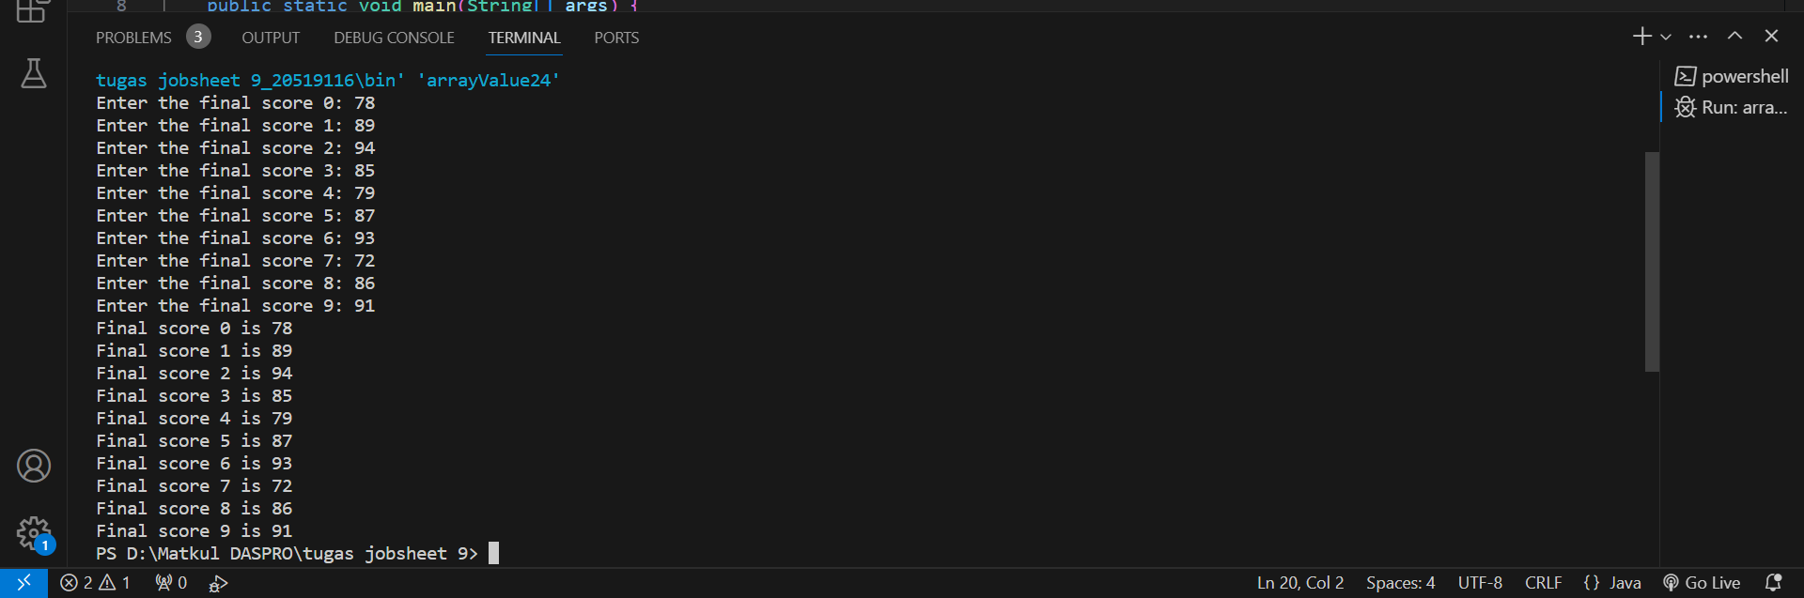

Questions!

1. Change the statement in step 5 to be like this Run the program. Have there been any changes? How can it be like that?

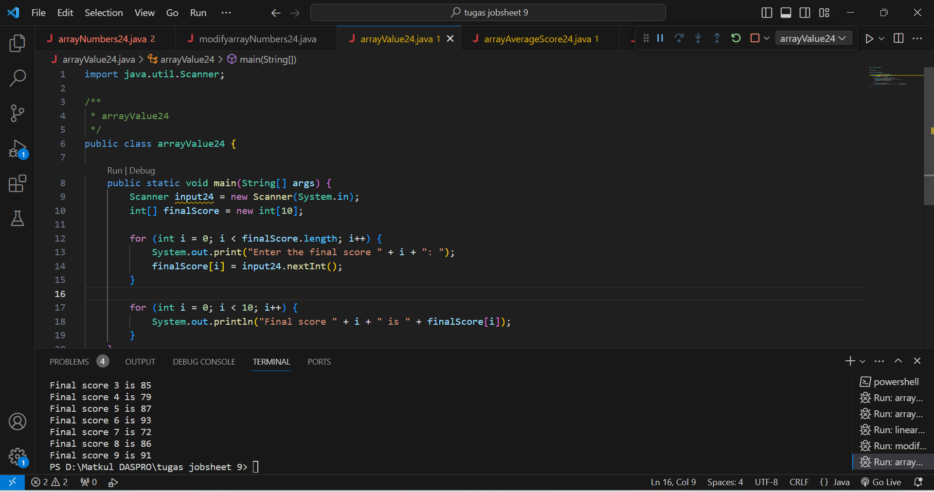

When we run the program, there is no change at all in the output, why? because the function of the previous program code with the new one is the same, so the output produced is also the same.

1. What is meant by condition i < finalScore.length?

Refers to the programming condition used in the looping structure, such as a for statement.

1. Change the statement in step 6 to be like this, so that the program only displays the grades of students who passed, students who have a score > 70 Run the program and describe the flow of the program!

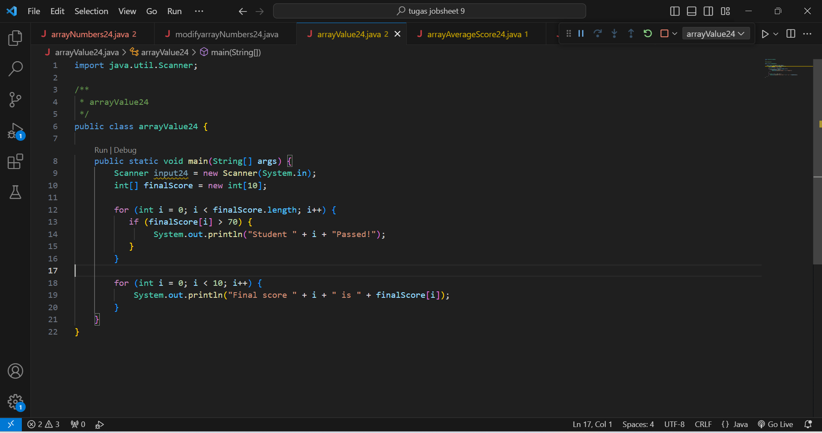

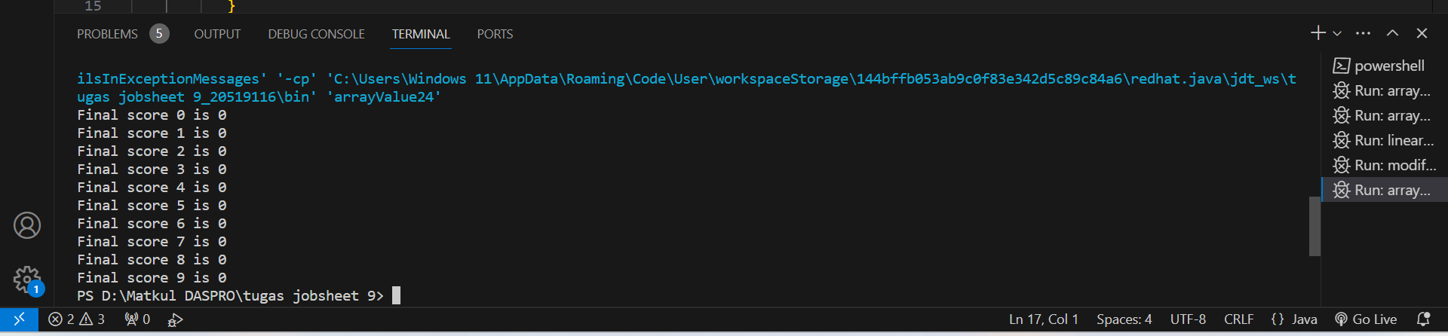

When we add the requested program code, when we run it, the result that comes out is 0, why? because the code includes the data type in boolean.

1. Modify the program so that it displays all students, and mark which one passed, and which did not!

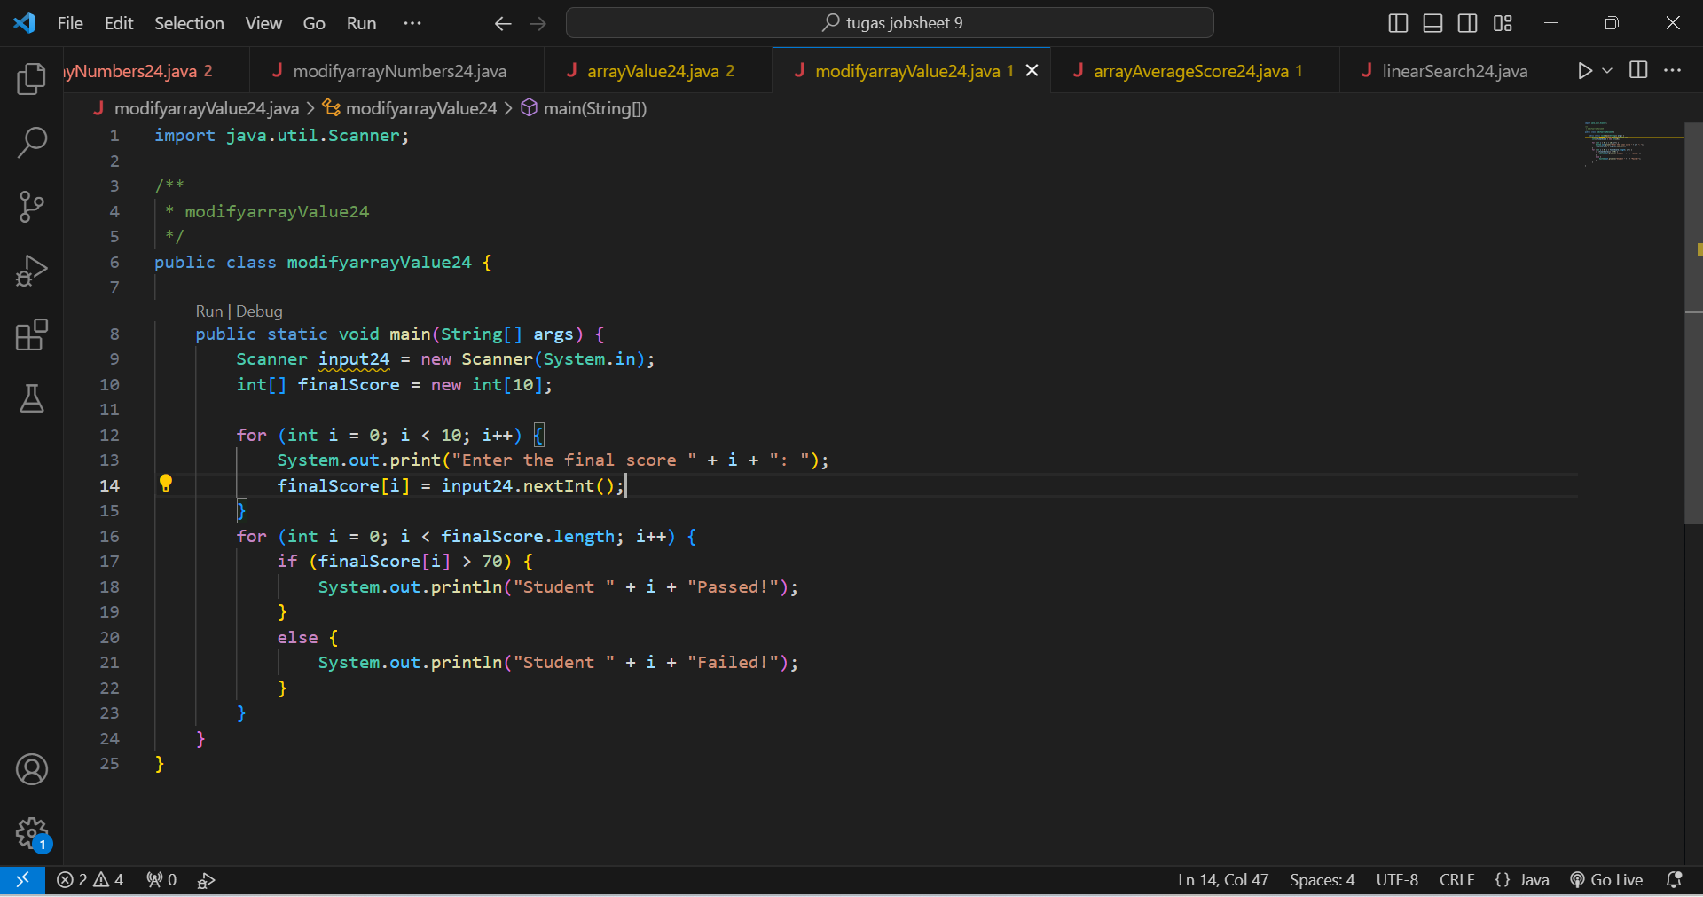

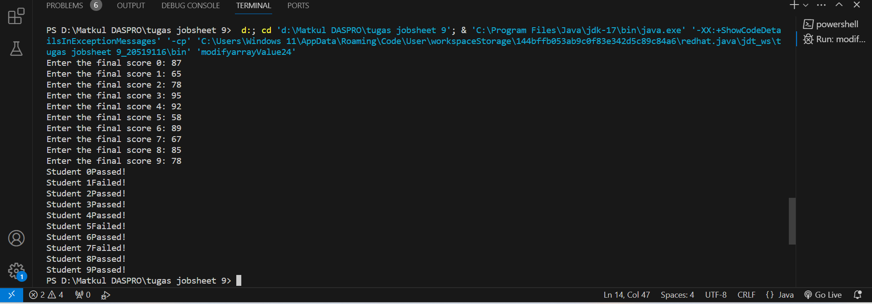

1. Commit and push the changes to GitHub.

**EXPERIMENT 3**

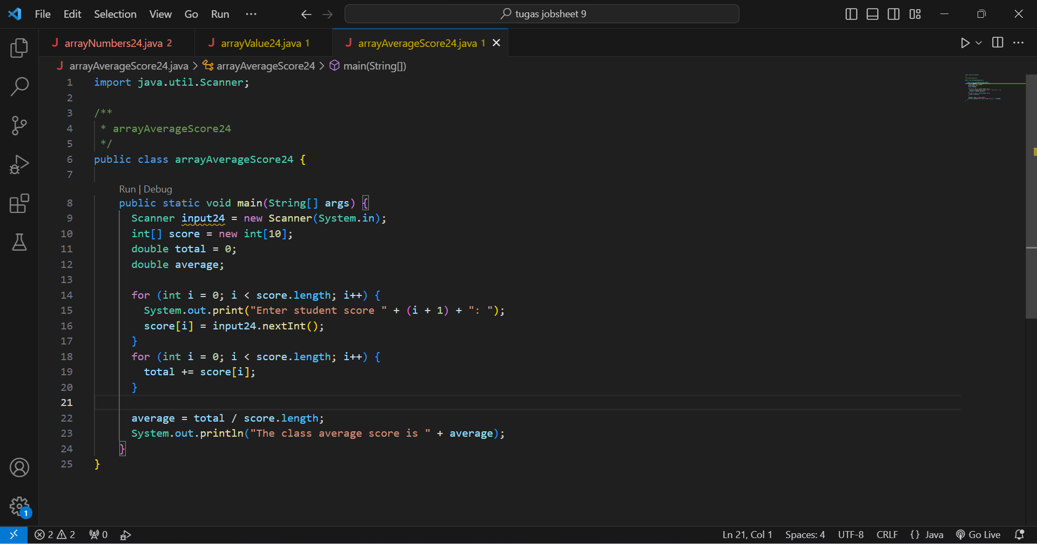

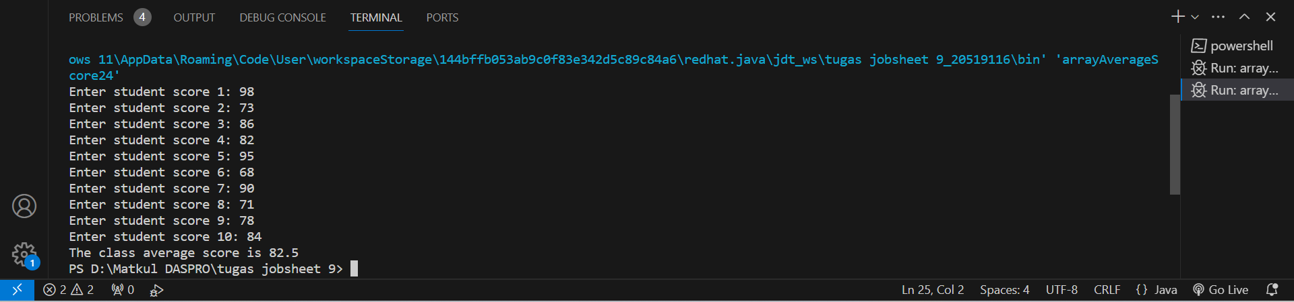

Questions!

1. Modify the program in Experiment 3 so that the program can display the number of students who passed, students who have a score greater than 70 (>70)

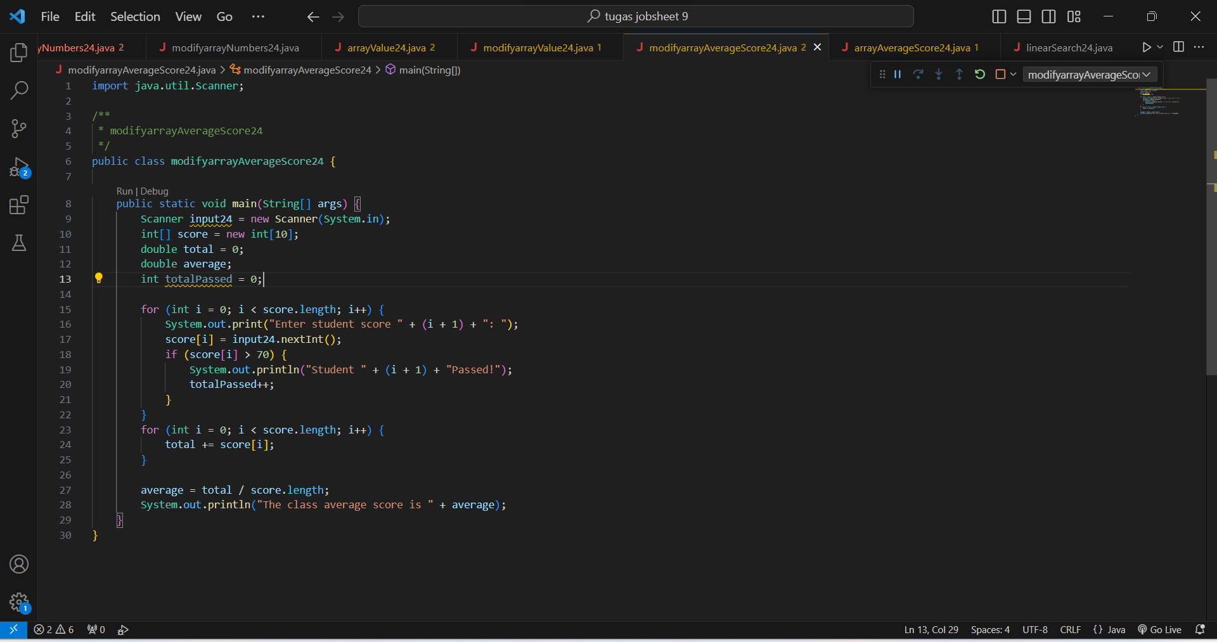

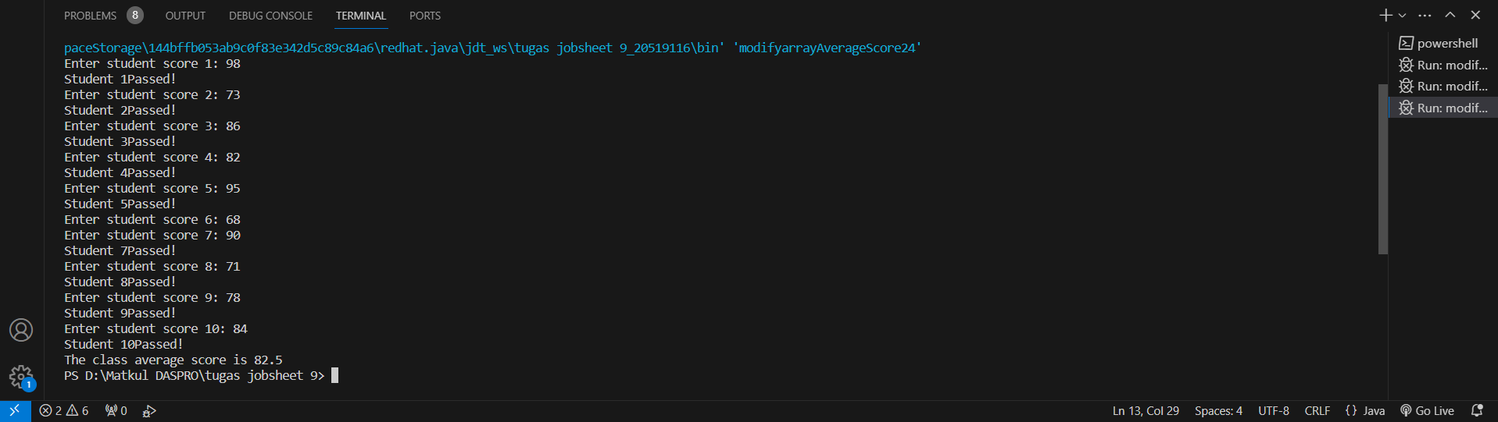

1. Modify the program in Experiment 3 so that it can produce output like the following display

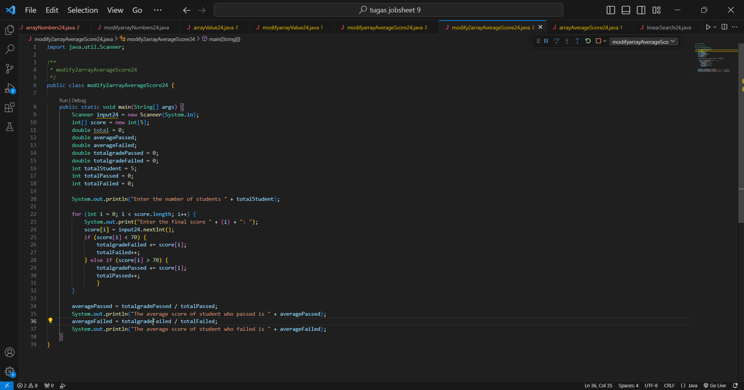

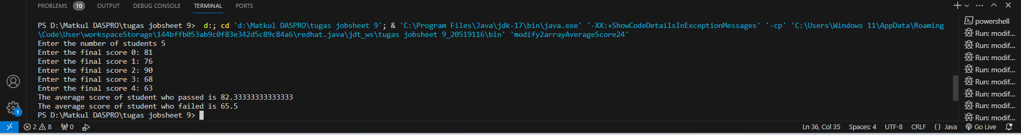

1. Commit and push the changes to GitHub.

**EXPERIMENT 4**

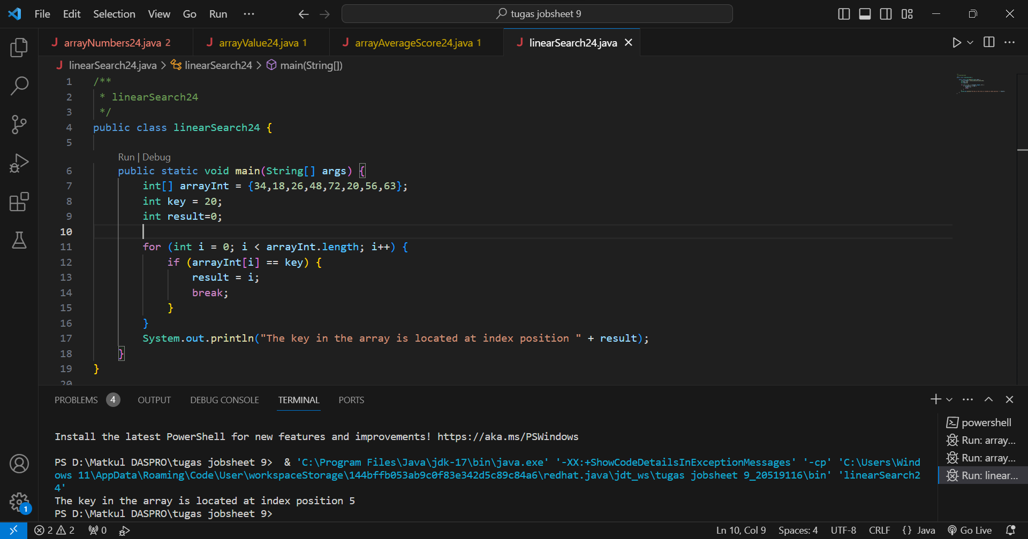

Questions!

1. Explain the meaning of the break; statement on line 13 of the program code in Experiment 4.

The break function is to stop the program code from running in the "for" loop after the condition is met.

1. Modify the program code in experiment 4 so that the program can receive input in the form of the number of array elements, the contents of the array, and the key you want to search for. Then, print to the screen the index of the element positions of the searched key. Example of program results:

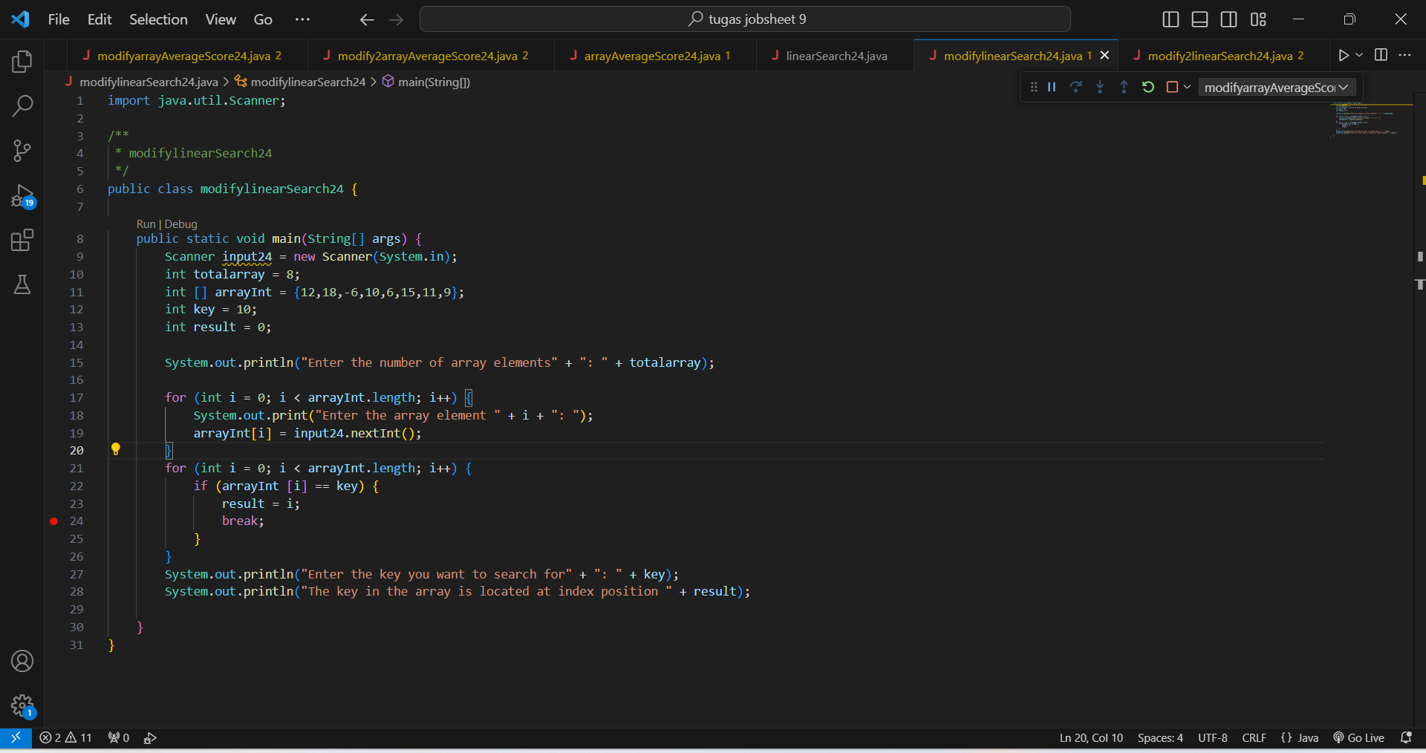

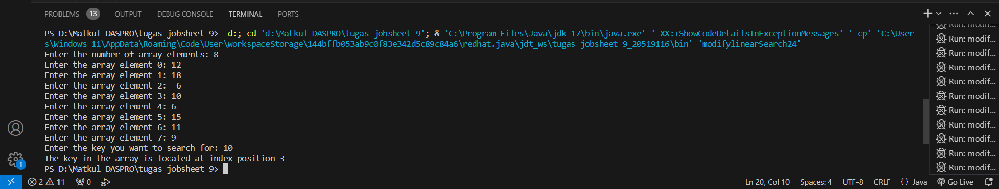

1. Modify the program in experiment 4 so that the program will give the message "key not found" if the key is not in the array. Example of program results:

